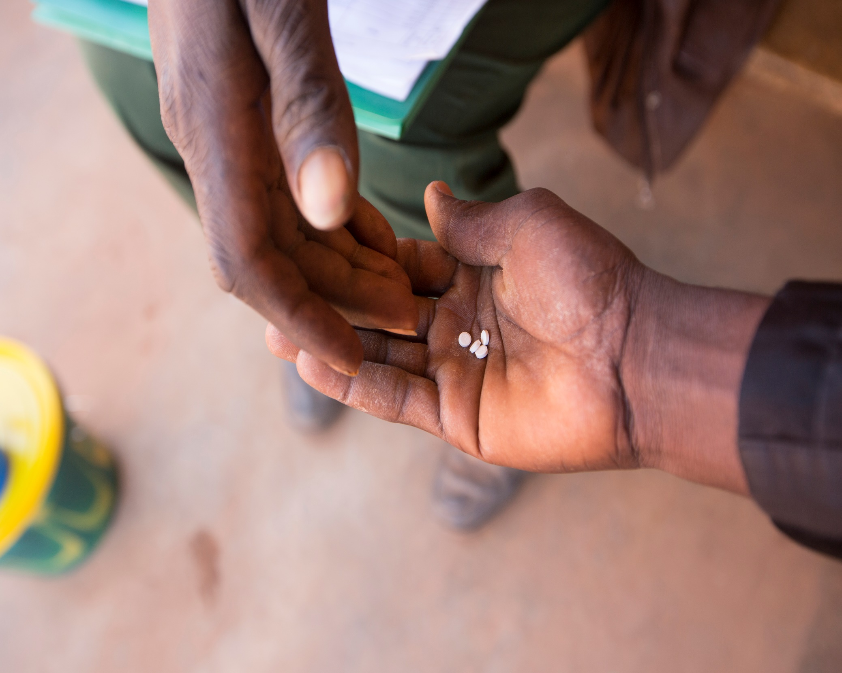
Stage 1 - Concept Application
Ascend Learning & Innovation Fund

Instructions
Before completing this form, please review the Fund Guidelines for challenge statements, fund logistics and eligibility criteria. The Concept Application is the first stage of the application process for the Ascend Learning and Innovation Fund. It is meant to provide an overview of the proposed project. Each Concept Application will be reviewed by the fund team to assess the eligibility, impact and suitability of the proposal for the fund. You can find additional information on how the proposal will be assessed by our reviewers in the Fund Scoring Criteria document.
To be considered, applications must:
- Be in English
- Be submitted in PDF or Word format
- Must not exceed the specified word limits
- Must not use a font smaller than 11 point
Once you have completed the application, please email it to fundteam@ascendwest-innovationfund.org. If you have any further questions, please feel free to contact the fund team at the same email address.
We look forward to receiving your Concept Application!

Project Summary
Project title:
[Your text here]
Project summary: Please summarise the project in 3-5 sentences addressing the following questions:
- What is the problem you are addressing?
- How will your project address the problem?
- What potential benefits would your project deliver?
[Your text here]
Innovation: Please describe the innovative or inventive aspect of the project in 1-2 sentences.
[Your text here]
Project timing: Please state the length of time for which you are applying for funding and proposed start and end dates. Projects must be concluded by January 2022.
[Your text here]
Funding amount: Please state the total amount of funding you are applying for in GBP (£).
[Your text here]

Applicant Summary
Organisation Information
Main application contact: Please include name, email and phone number (with country code).
[Your text here]
Organisation name:
[Your text here]
Registration or charity number (if applicable):
[Your text here]
Organisation address:
[Your text here]
Organisation website:
[Your text here]
Organisation Classification:
Please select the most relevant organisation classification option:
☐ Non-Profit Organisation
☐ For-Profit Organisation
☐ Government Institution
☐ Academic Institution
☐ Other - Please specify below
[Your text here]

Please select the most relevant option for your organisation based on where you are applying from:
☐ HQ
☐ Local branch (A branch office of an organisation)
☐ Local organisation (operating in a single country only)
☐ Academic institution
☐ Other - Please specify below
[Your text here]

Link to your organisation’s audited accounts for the last financial year, or equivalent, to demonstrate your organisation’s economic/financial standing:
[Your text here]

Organisation Experience
Experience summary: Please provide a summary of your organisation’s project management experience that is relevant to neglected tropical diseases (NTDs) and the project proposed here. 150 words maximum, bullet point format will suffice.
[Your text here]
Additional Information: Please list links to any relevant websites, published reports, annual reviews, etc.
[Your text here]

Implementation Partners (If Any)
Please provide the following details on implementing partners for this project, i.e. those that will be managing project funds. This must include all offices of the applicant that have a role in the project.
Organisation name:
[Your text here]
Organisation address:
[Your text here]
Organisation website:
[Your text here]
Brief description of their roles and responsibilities in this project: 100 words maximum, bullet point format.
[Your text here]
Brief description of engagement with proposed implementation partners: 250 words maximum.
- Who has been involved in the project design process and over what period of time?
- If implementation partners are yet to be engaged, please outline your planned consultation process?

[Your text here]

Concept Summary
Disease & Thematic Area
Please select the disease(s) that this project will address.
☐ Lymphatic Filariasis
☐ Onchocerciasis
☐ Schistosomiasis
☐ Soil-transmitted Helminths
☐ Trachoma
☐ Other – please specify

Please select the thematic area(s) that this project will address. Please refer to the fund guidelines for further details on activities in each thematic area.
☐ Service Delivery (e.g. supply-chain management)
☐ Health Workforce (e.g. training of human resources)
☐ Programme Effectiveness (e.g. treatment coverage)
☐ Patient & Provider Safety (e.g. compliance with surgical protocols)
☐ Medical Products & Equipment (e.g. maintenance/storage of surgical equipment)
☐ Water, Sanitation & Hygiene (WASH) (e.g. hygienic services)
☐ Behaviour Change Communication (BCC) (e.g. facial cleanliness campaign)
☐ Other – please specify

Geography and Population
Project location(s): Please name the country/countries and region/district(s) where this project will take place.
[Your text here]
Target population: Please name and describe the target beneficiaries for this project. If applicable, please also state the estimated number of expected beneficiaries. 100 words maximum.
[Your text here]
Inclusion: Please outline the approach for adhering to FCDO’s commitment to leave no one behind (link) – how will you prioritise reaching the most marginalised and vulnerable population groups, including persons with disabilities? 200 words maximum.
[Your text here]

Project Background
Context: Please describe the problem/challenge that this project is addressing. 200 words maximum.
[Your text here]
Evidence: What evidence do you have that this is an effective and appropriate approach to address the identified problems at this time, in this location? 200 words maximum.
[Your text here]
Beneficiary feedback: Please provide details of beneficiary input or feedback from previous programmes which can inform this project? 150 words maximum.
[Your text here]

Challenge Statement
Please select the challenge statement(s) that this project will address. Please refer to the fund guidelines for further detail on the challenge statements if needed.

☐ COVID-19 Response – How can adaptive NTD delivery ‘build back better’ in the context of COVID-19?
☐ Integration multi-sectoral action – How can NTD interventions leverage synergies arising from integrations across diseases, sectors and/or borders?
☐ Universal Health Coverage (UHC) – How can we enhance access to, and quality of, integrated NTD treatment and prevention services in the context of UHC?
☐ Health Systems Strengthening (HSS) – How can we ensure long-term in-country sustainability for integrated NTD programmes?
☐ Data – How can we increase the quality, availability and usage of NTD data at all levels?
☐ Other – please specify
Objectives and impact: Please describe the project’s objectives and how they will make an impact in line with the challenge statement(s) selected above. 200 words maximum.
[Your text here]
Project design: Please describe the activity plan for achieving the project’s objectives, including methods to be used. 250 words maximum.
[Your text here]
Key outputs: Please describe the measurable outputs that will be used to monitor the project. 150 words maximum.
[Your text here]

Innovation
Innovation in this context is not just limited to high-tech or brand-new solutions, but is about i) developing and testing creative solutions to known challenges ii) learning and an openness to adapt, as innovation has an inherent risk of failure and iii) supporting a vision for scalability and increasing impact. Examples of innovative work may include bringing in learning from outside of the NTD sector or bridging the gap between research and implementation.

Innovation: Please select whether you would categorise this project as Core, Adjacent or New innovation.
☐ Core – Incremental improvements on what is currently being done
☐ Adjacent – Transferring methods or approaches from one context (e.g. country, sector or scale) to another
☐ New – Novel inventions or ways of doing things

Innovation description: Please provide a description of the innovative aspect of the concept and why you have chosen the innovation category above. 150 words maximum.
[Your text here]
Innovation process: What was the process that led to your idea? 100 words maximum.
[Your text here]

Future Steps
Sustainability, replication and scaling: Please describe your next steps if this project is effective. 200 words maximum.
- How you will make this project sustainable for the long-term?
- What future replication and/or scaling opportunities are there?
- What will you commit to if this project is successful?
[Your text here]

Country-level Engagement
Country-level Engagement
Country consultation: Please provide details of any engagement and consultation with national governments and their support for this project to date. Include details of ministry departments consulted if relevant. 100 words maximum.
[Your text here]

Budget
Budget
Total budget: Please provide an estimate for the total funding request for this project in GBP (£). Kindly provide an indication of the categories of spend as specified in table below. (NB: A detailed budget is required at proposal stage).

Item Description | Cost in GBP (£) | Budget Allocation
Personnel
Consultants
Equipment
Digital Spend
Travel
Other Activity Costs
Other Support Costs
Total Budget |  | 100%

[Your text here]
Cost drivers: Please list the main cost drivers for this project, i.e. what factors will most impact the cost of this project? Please briefly describe how costs relate to planned activities and target outcomes. 150 words maximum.
[Your text here]
Equipment: Are you requesting funding for any equipment purchases over £500 ($650 USD) or other valuable assets (e.g. phones, tablets or computers)? If yes, please provide a brief description of the equipment, reason and estimated cost. 100 words maximum.
[Your text here]
Risks and mitigations: Please identify the main risks for this project and any plans to mitigate those risks. 150 words maximum.
[Your text here]
Co-funders (if any): Please list co-funders for this project, if any, and how much funding they are expected to provide.
[Your text here]

Compliance
Compliance
Compliance and due diligence: Please check all the following that apply, so that we may understand compliance requirements for the project. Note that if none of the below apply for your organisation, it will not preclude you from being eligible for funding. All successful applicants will need to sign up to the FCDO Supply Partner Code of Conduct (link) and the Sightsavers Code of Conduct, and due diligence checks will be undertaken before any funds are awarded.
☐ My organisation is an Ascend West and Central Africa partner
My organization is an Ascend East Africa and South Asia partner
☐ My organisation has previously received Sightsavers funding
☐ My organisation has previously received FCDO or USAID funding
☐ My organisation is a UK-based entity
☐ This project proposal includes research involving human subjects
☐ None of the above apply for my organisation

Additional Documentation: The following documents are required for due diligence and compliance checks at this stage. Please select the relevant documents that you have appended.
- Government Ministries must append the following documents (or provide URL).
☐ List of senior ministers
☐ Most recent Auditor General's report
☐ Legislation/policies relating to safeguarding, child protection, or vulnerable persons

- Non-Government organisations must append the following documents (or provide URL):
☐ Governing document e.g. Constitution, Articles of Association (for non-profits only)
☐ Registration certificate (including, where relevant, most recent renewal)
☐ List of Trustees and Directors
☐ Most recent audited financial statements (or Auditor General's report)
☐ Most recent auditor's report and management letter (or Auditor General's report)
☐ Safeguarding, child protection, or protection of vulnerable persons policy

Please specify a reason if you are not able to append any of the required documents
[Your text here]

Additional Information: Please provide any additional information you feel may be relevant for compliance or due diligence.
[Your text here]

Additional Information
How did you hear about this fund?
Please check all that apply.
☐ Internal Ascend West and Central Africa consortium communications
☐ Liverpool School of Tropical Medicine website and/or communications
☐ Mott MacDonald website and/or communications
☐SCI Foundation website and/or communications
☐ Sightsavers website and/or communications
☐ Word of mouth
☐ Other: please specify
[Your text here]

