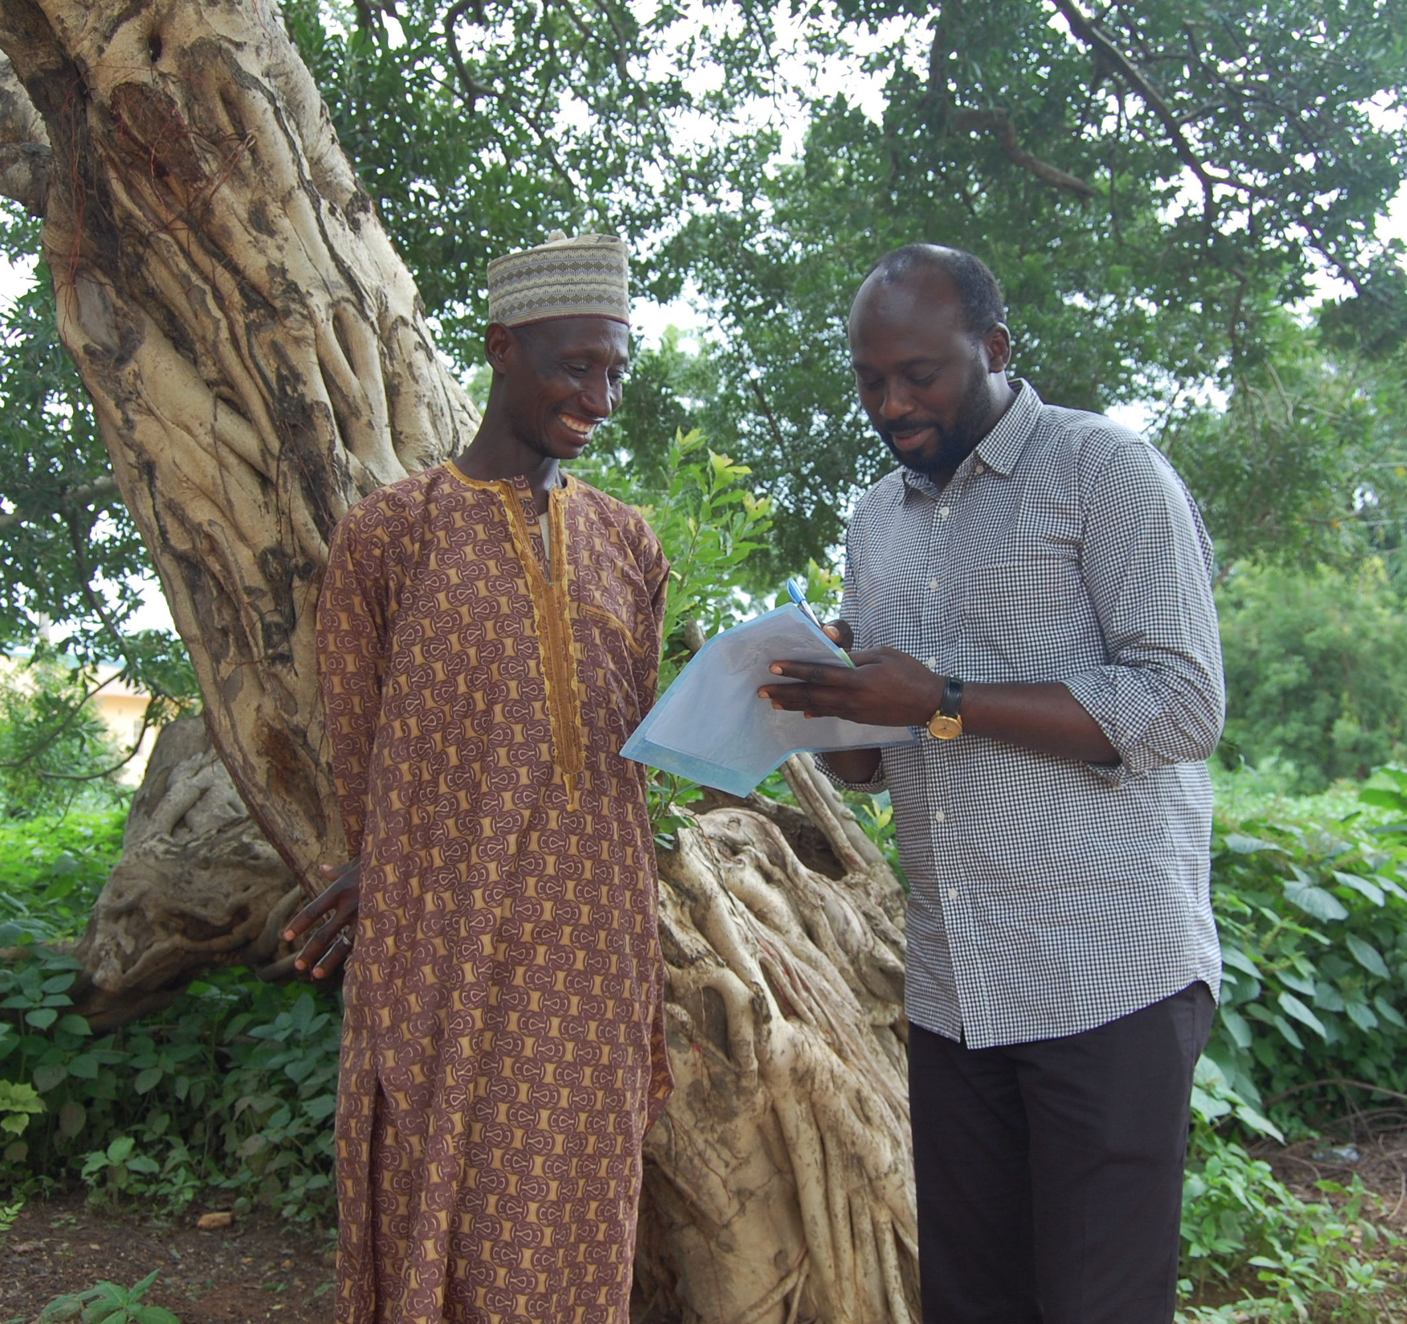
Budget Guidelines
Ascend Learning & Innovation Fund
Budget Guidelines

1. Introduction
These guidelines have been established for applicants to the Ascend West and Central Africa Learning and Innovation fund.
The purpose of this document is to provide clear guidance on the process for budgeting activities, and to clarify what will be allowable. Sightsavers has a clear responsibility to ensure that this programme achieves its objectives and delivers value for money.
If you have any questions on these guidelines or on the budget template, please contact the Fund Team at fundteam@ascendwest-innovationfund.org.

2. Budgeting (including budget updates)

2.1 The Overall Budgeting Process
All applicants should adopt appropriate practices to ensure that best value is obtained for the project. Expenditure must be based on approved budgets and there are specific rules around certain costs to ensure that the Foreign, Commonwealth and Development Office (FCDO) are obtaining value for money.
Economies of scale may be achieved for all equipment and consumables through consolidated procurement at a national, regional or programme level. FCDO have specific rules around equipment and must approve procurement of some equipment in advance. See the Equipment section of these guidelines for more information on this requirement.
Any potential conflict of interest should be declared to the Fund Team up front. Approval should be obtained from the Fund Team prior to undertaking any financial transaction with the party concerned.
Applicants also need to be aware of the requirements of the UK Bribery Act. They should ensure that they do not undertake any activities that could be construed as bribery, such as providing facilitation payments. If you suspect any fraud in connection with expenditure incurred on this project you should immediately report it to the Fund Team, to Sightsavers (whistleblowing@sightsavers.org) or directly to FCDO (reportingconcerns@fcdo.gov.uk) as per the Whistleblowing Policy.

2.2 Budget Templates and Cost Lines
We do not require detailed budgets to be submitted with your concept application, however an indication of your budget and the categories of spend required helps us in the review process. There is space for this in the concept application template.
If you are invited to submit a detailed application, budgets need to be established using the budget template provided by the Fund Team. If your application is approved, we may require you to include further information or detail in your budget, so the more detailed information you are able to provide up front, the quicker this process should be.
In addition, reasonable requests for costs to be grouped in a certain way to enable fair comparison across applicants and countries may periodically occur. It is also likely that FCDO may have ad hoc requests relating to unit costs and value for money information during the period of the fund. You will be given as much prior notice as possible to provide this information.
We have provided the following information to help you understand what should be included in your budget. Please note that we require an overall budget for each category below in your concept application and an itemized budget as described for each category for your detailed application.

Personnel
Any staffing costs that are included must be itemised by person and by the % of their time that has been budgeted to the project. Pooled staffing costs, where costs are not allocated on the basis of time spent working on a specific project, will not normally be permitted. Staff costs should not represent more than 60% of the total budget unless there is a clear justification that this is necessary to achieve value for money in the context of the project.

Consultants
Consultants must be itemised by person and by the number of days that have been budgeted to the project.
Any consultants who are budgeted at over £25,000 will require separate approval from FCDO, and these positions may need to go through an external tendering process unless you are able to provide strong justification about why a specific consultant should be used.

Equipment
Include any equipment or assets to be purchased for your project in this section. Advance approval from FCDO will be required for any spend on this line which falls within the below definition of an asset. It is important that any equipment requirements of your project are included in your proposal and budget so that we can obtain this approval in advance of the start of the project. We will inform you once the equipment has been approved. The Fund Team must be consulted before any procurement processes are undertaken if you have not received this approval.
Assets are classed as equipment and/or supplies which:
- Have a useful life of more than one year; and either
- The purchase price or development cost of the asset is in excess of £500 or equivalent in local currency; or
- The asset is part of a group of lower value items where the combined value is in excess of £500 or equivalent in local currency; or
- The asset can be considered an attractive item regardless of cost (e.g. mobile phones, cameras, laptops, tablets, satellite phones, vehicles, etc.)
Applicants can use their own procurement processes, as long as these do not conflict with contractual requirements, but these must ensure that any procurement using contract funds meets international good practice, untied and free of narrow national self-interest, using transparent processes, transparently fair and open competition, and good contract management, including prevention of malpractice, bribery and corruption.
Applicants should source goods and services from suppliers that clearly offer value for money, and whose workplace practices meet corporate social responsibility standards.

Digital Spend
Digital spend requires pre-approval from FCDO. Please see guidance for whether your spend falls into this category here:
https://assets.publishing.service.gov.uk/government/uploads/system/uploads/attachment_data/file/920612/FCDO_Digital_Spend_Guidance_for_Suppliers_and_Partners.pdf
It is important that any digital spend is included in your proposal and budget so that we can obtain this approval in advance of the start of the project. There is an additional form for FCDO approval of this which can be provided by the Fund Team. We will inform you once the equipment has been approved, so the Fund Team must be consulted before any procurement processes are undertaken if you have not received this approval.

Travel
Lump sums or provisions for travel will not be permitted. Average trip costs based on activity should be prepared.
Additional information on what should be considered when budgeting for travel is included below.

Accommodation
Hotels used should provide secure and comfortable but not luxurious accommodation, such that those working on the project are in a fit state to carry out their duties during the day. 5* hotels or their equivalent will not be funded (expenditure will be rejected) and an explanation should be provided in circumstances where it has proved necessary to use a hotel that is above mid-range. The Fund Team will not accept the following hotel related expenses:
- Newspapers
- Mini bar drinks and snacks
- Video / television charges for in room movies
- “no show” costs
- Laundry
- Tips or gratuities
- Alcoholic drinks
For locations where hotel accommodation is not available, an accommodation allowance may be claimed.

Meals and Drinks
Meals and an accompanying non-alcoholic drink will be accepted subject to the retention of a valid receipt and confirmation of number of covers. Records retained should make it clear that only personnel working on the project are being claimed for and that the cost per person is reasonable given the location. Where hotel meals are included in the total price (such as breakfast) an alternative meal option is not allowable. Additional water/non-alcoholic drinks required during the day are an acceptable expense.
Please be aware that FCDO policy states that alcohol cannot be charged to the programme.

Modes of Transport
Internal or international flights needed for the purposes of the project can be charged where budgeted. Booking invoices and boarding passes should be kept as evidence of flights taken. Only flights with a class of travel that is no more than ‘standard economy’ are reimbursable.
Applicants are expected to claim using their standard mileage rate (to cover the cost of fuel and a % add on for maintenance and insurance). All mileage rates should be approved as part of budget with the submission of the basis of calculation. When claiming for mileage, details of distance covered, and places visited will be needed and it is expected that authorised vehicle logbooks will be retained as evidence of mileage covered.
Where applicants do not have a mileage rate, fuel receipts will be reimbursed, again accompanied by details of mileage undertaken and places visited, substantiated by authorised vehicle logbooks. Reasonable vehicle repair and maintenance costs relating specifically to project activities will be funded, subject to overall budget ceiling.
Costs of public transport and taxis incurred in the course of project business, including travel to and from airports, may be claimed if there is supporting documentation such as a valid receipt. Taxis are a very expensive way to travel in some countries and should be avoided in favour of buses and trains where possible. Receipts must be obtained for any taxi fares and an explanation given where there is no receipt. Tickets should be retained for any other forms of land transport.
It is expected that applicants will usually be able to use their own, Ministry of Health, or project vehicles for project activities. However, if it is anticipated that vehicle hire will be necessary this should be included in the project budget and be properly documented with a contract for vehicle hire and invoices for payment. The Fund Team will not fund vehicle hire payments if it is apparent that the vehicle has not been used solely for project activities, so clear records of mileage undertaken, and locations visited should be retained.

Per Diems
If it is standard practice for applicants to fund expenses using per diems, this should be reflected in the budget. Per diem rates must be approved at the budget stage and it should be clear what is covered by the per diem rates used (e.g. some cover accommodation and some do not). Receipts for other categories of expenditure referred to in these guidelines (such as accommodation, food, travel, telephone) will not be refunded where there has been payment of a per diem to cover these.
In general, per diem rates should be based on an appropriate scale (e.g. government rates, set rates per organisational policy). Per diem rates for Ministry of Health staff should be standard across partner budgets in any one country.
Per diem payments should be documented by signature and formal receipt from the person who has received the payment, and where at all possible should be paid by bank transfer rather than cash.

Other Activity Costs
Any direct costs relating to your project activity which have not been included elsewhere should be included here. Please include budget notes explaining what this figure is made up of.

Venue Hire
Training activities may require hire of an appropriate conference venue. Negotiation of ‘cost per delegate’ packages is acceptable. It is expected that appropriate procurement practices are applied to ensure a competitive price, providing good value for money.

Other Support Costs
In-country office running costs that can be directly attributable to the project may be budgeted here, along with other direct costs which do not fit into other categories. As this is a broad category, please include information in the Item Description and Budget Notes columns.

Phone Costs
Where it can be demonstrated that additional mobile phone costs have been incurred, these can be claimed. Airtime vouchers or mobile phone invoices should be kept to record this expenditure. Excessive mobile phone claims will be queried as this expenditure should only relate to calls necessary to project activities when out in the field.
Landline calls and data usage charges incurred in connection with the project can be funded to the extent clearly identifiable on phone bills. Additional contributions to line rental etc. are not allowable.

2.3 Lump Sums and Units in Budgets
Detailed Budgeting (after project approval): Lump sums should be avoided in budget lines and may not be approved.

2.4 Things to remember when budgeting
The following resources are often necessary for running an NTD project (depending on the activities) but are often left out of submitted budgets.
- Staff related costs (e.g. recruitment costs, training, benefits and statutory payments)
- National planning and other evaluation meeting costs
- Vehicle maintenance and running costs
- Equipment maintenance (e.g. for photocopiers and computers)
- Surgery audit costs
- Shipping and clearance taxes

2.5 Budget Template
You should complete all yellow columns on the budget template. Please note that the template guidance below is only applicable for the Detailed Application phase.
- Region: If you are working in multiple regions you should duplicate lines if they contain regional costs.
- Item description: You can amend the item description on each row as required, but make sure to group like items under the categories provided.
- Budget Notes, Unit Cost, Unit: All budgets submitted should be accompanied by budget notes clearly explaining how the costs are required for the activities and outputs agreed. These should be included in the ‘Budget Notes’ column of the budget template. The notes should allow someone to understand what each line is, why it is necessary for the project and how it has been calculated. They should be structured in terms of unit costs e.g. how did we calculate the unit cost, what does it include, what is the number of units.
- Number Required: You should include the number of units required for each period in these columns. The total will calculate automatically.

2.6 Budget Ceiling
All applicant expenditure reports are subject to the approved ceiling for each budget subheading. This corresponds to the agreed activities for that period. Any expenditure within a budget subheading in excess of 10% of the budget ceiling must be identified and approval sought from the Fund Team prior to committing to the expenditure
Only financial expenditure reports that are within the agreed budget ceiling will be approved. Please bear this in mind when budgeting.

