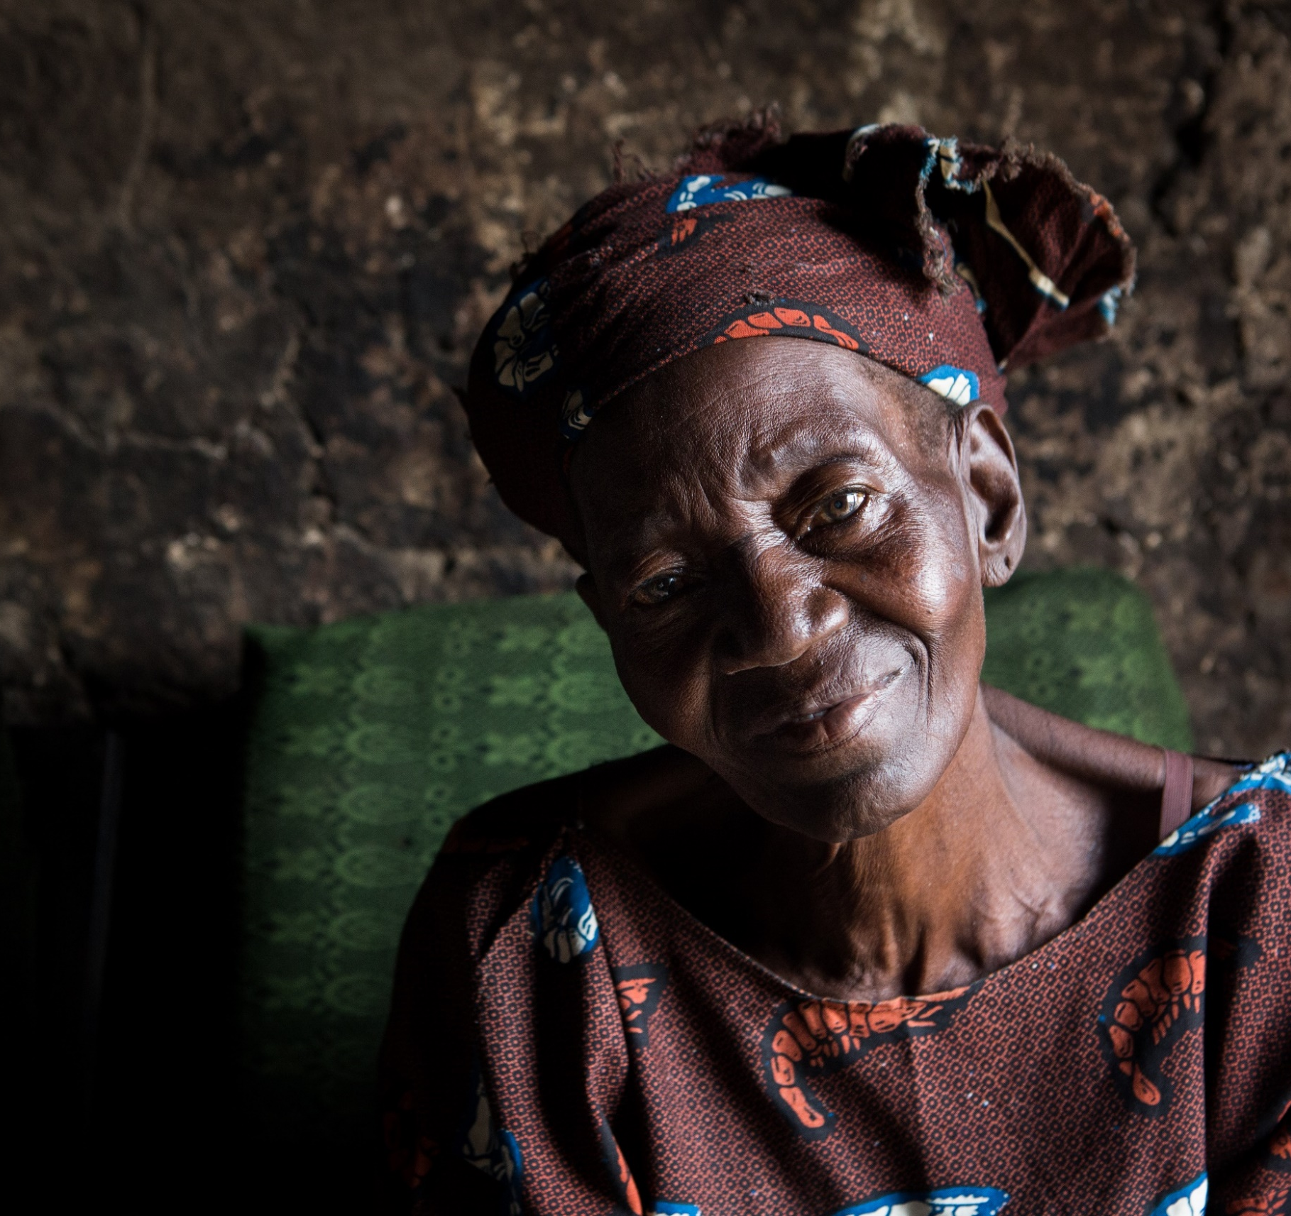
Ascend Activities Annex
Ascend Learning & Innovation Fund
Ascend Activities Annex

Ascend Activities Annex
The Ascend West and Central Africa programme is funded by the Foreign, Commonwealth and Development Office (FCDO), and is led by Sightsavers, the Liverpool School of Tropical Medicine (LSTM), Mott MacDonald and the SCI Foundation. It is a three-year programme (Apr 2019 – Mar 2022) aiming to deliver a minimum of 440 million treatments to accelerate control and elimination efforts for five NTDs. Specifically, the programme is contributing to the elimination of lymphatic filariasis (LF) and trachoma as a public health problem, making significant progress towards eliminating transmission of onchocerciasis (OV) and controlling morbidity of schistosomiasis (SCH) and soil-transmitted helminths (STH).
The programme runs in 13 countries in close partnership with their ministries of health: Benin, Burkina Faso, Central African Republic, Chad, Cote d’Ivoire, Democratic Republic of the Congo, Ghana, Guinea, Guinea Bissau, Liberia, Niger, Nigeria and Sierra Leone.
The main project activities fall under the following categories:
- Prevention and treatment, including mass drug administration (MDA) for onchocerciasis, lymphatic filariasis, trachoma, schistosomiasis and soil-transmitted helminths, where treated in conjunction with schistosomiasis; surgery for lymphatic filariasis and trachoma cases; morbidity management for lymphatic filariasis cases; and social behaviour change communication for preventive hygiene practices and increasing uptake of MDA.
- Increasing the integration of aspects of NTD programmes within domestic health systems where this is feasible, while ensuring in fragile and conflict affected states that opportunities to develop a health system as countries transition are not undermined by programme activities.
- Strengthening the national health system - integrating efforts to strengthen the relevant building blocks of the health system both by building capacity and integrating targeted interventions where feasible for sustainable delivery of NTD control and elimination activities.
- Data for targeting and monitoring, including mapping of NTDs where this has not yet been completed, coverage surveys, impact assessments and alignment of NTD monitoring with national and international monitoring systems, processes and data storage.
- Cross‐sectoral coordination, in particular between the health and water, sanitation and hygiene (WASH) sectors, to encourage targeting of WASH investments based on NTD burden, and with the education sector, as appropriate for school‐based interventions.
- COVID-19 response has also been included as part of the funded activities due to intersectionality with the NTD activities above with the goal of reducing the transmission of COVID-19, through activities detailed below.

A summary of the activities related to prevention and treatment by country are noted in the table below, with further details below on other programme areas.
Country | LF treatments | OV treatments | Trachoma treatments | SCH treatments | STH treatments | Trichiasis trachomatous surgeries | LF Morbidity Management Disability Prevention
Benin
Burkina Faso
CAR*
Chad
Cote d’Ivoire
DRC
Ghana
Guinea
Guinea-Bissau
Liberia
Niger
Nigeria
Sierra Leone

Table key: Blue signifies where the activities are taking place in the country.
*All programme activities are pending in CAR.

Mass Drug Administration (MDA)
- Provision of MDA for lymphatic filariasis, onchocerciasis, schistosomiasis, soil-transmitted helminths and trachoma.
- Production, revision and printing of information, education and communication (IEC) materials.
- Sensitisation of communities to MDA.
- Mobilisation of schools, parents and communities.
- Monitoring and supportive supervision of school and community-based MDA.
- Production of MDA distribution reports.
- Conducting post-MDA review meetings with key actors.

Morbidity Management and Disability Prevention (MMDP)
- Active case finding and identification for lymphoedema, hydrocele and trachomatous trichiasis (TT) patients.
- Case verification by health professionals.
- Provision of lymphoedema management services.
- Provision of hydrocele surgery.
- Provision of TT surgery.
- Surgical follow-up for hydrocele and TT surgery.

Training
- Training of national, regional and district level NTD staff on lymphoedema management.
- Training of hydrocele and lymphoedema case finders.
- Training of surgeons on hydrocele surgery.
- Training of surgeons on TT surgery.
- Training of community drug distributors.
- Training of teachers for drug distribution using the school-based platform.

M&E: Mapping and surveys
- Lymphatic filariasis: baseline, sentinel site, pre-transmission assessment survey (TAS), TAS (1,2,3), post TAS surveillance.
- Onchocerciasis: elimination mapping, impact survey, breeding site assessment, pre-stop MDA, stop-MDA.
- Schistosomiasis and soil-transmitted helminths: sentinel site assessment, baseline, impact survey.
- Trachoma: baseline, impact survey, surveillance survey.
- MDA coverage evaluation survey.
- Health facility assessments for LF MMDP.

Health Systems Strengthening (HSS)
The programme is focusing on:
- Strengthening relevant building blocks of national health systems and supporting countries to provide the prevention, detection, treatment and surveillance activities necessary to maintain the reduced disease burden in the longer term and to prevent disease resurgence.
- Increasing the integration of aspects of NTD programmes within domestic health systems where this is feasible.
Activities supported include regional and country engagements, country assessments using the Dalberg NTD sustainability assessment, prioritisation and strategy development to ensure synergies with WHO and other NTD partners and the development of integrated HSS operational plans. Health system strengthening activities are tailored for each country in acknowledgement of variations in the national health systems in each country and the current status of the national NTD programmes and disease elimination targets being implemented in each one.

Supply chain capacity building
Ascend is developing a capacity building strategy for supply chain by supporting the availability of donated drugs at the subnational level for MDA, namely by:
- Working in collaboration with National NTD Programmes, stakeholders and partners to identify needs and gaps and agreeing priority activities for capacity building.
- Improving demand forecasting through developing the skills and capacity of national NTD teams to be able provide accurate information to WHO and the International Trachoma Initiative.
- Improving standard procedures and training for the proper management of donated drugs before, during and after MDA, which reinforce key elements of the national health supply chain.

Water, Sanitation and Hygiene (WASH)
- Conduct a landscape analysis in all Ascend countries apart from CAR: this is a process to compile and analyse national and district level information on WASH, NTD prevalence & programmes, behaviour change interventions, and their relationship to one another in a comprehensive report.
- Identify available data and information on partners and agencies: the WASH NTD data tool will be used to collate extensive WASH and NTD data from local districts and store it in a central database; convene a process for joint planning/decision making.

Behaviour Change Communications (BCC)
- As part of the Ascend programme, we will equip the NTD community with evidence-based BCC best practice to inform BCC programming and communications that will prevent further spread of NTDs. This will be done by:
- Conducting formative and primary research to establish strategic thinking and a series of guiding principles/protocols that counteract identified behaviours and attitudes contributing to the contraction of NTDs.
- Developing a nominal number of best-practice exemplary assets that in-country users across all 12 x countries can adopt, iterate with and deploy locally to either counteract negative behaviours or promote desired attitudes, norms and behaviours that can support prevention, help-seeking behaviours and treatment adherence.
- Best practice activations will be developed in Nigeria, DRC and Guinea Bissau which the rest of the programme can leverage as case studies
- Provision of capacity building and ongoing support via a call down function so that country teams can activate their own BCC interventions in line with the best practice and examples developed

COVID-19 Response
Since April 2020, the Ascend West and Central Africa programme has been adapted to support the COVID-19 response. As part of the response effort(s), the consortium is working with national governments to increase awareness of critical hygiene measures and reduce the transmission of COVID-19. Note that this is an evolving piece of work due to the nature of the pandemic and the scope below may change based on country need and FCDO approval.
A summary of the activities by country are noted in the table, with further details below.
Country | Mass communication | Community contact tracing | Case management | Sanitation supplies and equipment
Benin
Burkina Faso
CAR
Chad
Cote d’Ivoire
DRC
Ghana
Guinea
Guinea-Bissau
Liberia
Niger
Nigeria
Sierra Leone
Table key: Blue signifies where the activities are taking place in the country.
- Mass communication: Production of adapted materials and utilisation of communication tools (such as print messaging, billboards, radio, and television), as well as community sensitisation activities led by community health workers to target women’s groups, people with hearing impairment and minority language groups.
- Community contact tracing: Training of health workers and deployment of contact tracing / neighbourhood watch at the community level (identification, reporting, line-listing, and monitoring persons who enter the community).
- Case management: Training of surveillance officers and data managers on data entry and tools to conduct case investigation and reporting using COVID-19 data at a central level.
- Sanitation supplies and equipment: Provision of fabric masks, hand washing kits (buckets, basins and stands), soaps and alcoholic hand gels, particularly to healthcare facilities or to volunteers supporting the communication activities within the community.

