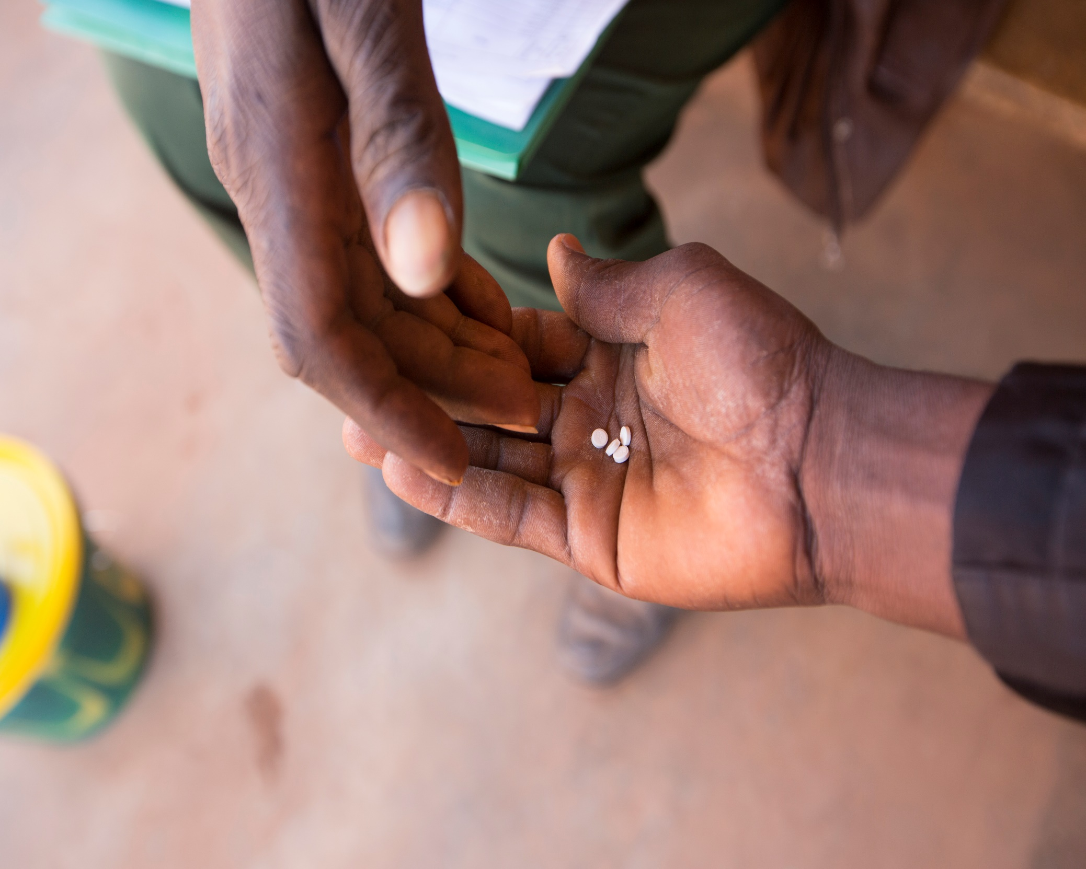
Fund Scoring Criteria
Ascend Learning & Innovation Fund

Contents
Overview 1
Eligibility Screening 1
Concept Application Scoring 2
Detailed Application Scoring 3

Overview
The Fund Team will score applications with the following criteria. Criteria for the Concept Application and Detailed Application are provided below. Please ensure your application meets the relevant criteria to increase your chances of success.
We look forward to receiving your application!

Eligibility Screening
- Does the proposal timeline fit within the fund timeline, with all activities and reporting completed by March 2022?
- Does the requested budget fit into the fund’s funding range of £20-500k??
- Is the applicant organisation eligible?
- Eligible organisations (see Fund Guidelines Section 4 - Eligibility):
  - Are legally registered organisations with their own constitution (applicable to non-profits only) and independent board of trustees.
  - Can provide published annual audited accounts or financial statements for the last two years and other documentation required for compliance (see Compliance section)
- Does the proposal relate to at least one of Ascend West’s target NTDs (lymphatic filariasis, onchocerciasis, schistosomiasis, soil-transmitted helminths, trachoma)?
  - We welcome proposals that include additional activities to tackle other NTDs included in the London Declaration on NTDs, where there is a strong case that these can be integrated based on geographical overlap with priority diseases, and a clear justification of need
- Does the proposal relate to at least one of Ascend West’s countries or their border regions (Benin, Burkina Faso, CAR, Chad, Cote d’Ivoire, DRC, Ghana, Guinea, Guinea Bissau, Liberia, Niger, Nigeria, Sierra Leone)?

Concept Application Scoring
Please ensure the relevant sections of your Concept Application meet the corresponding criteria to increase your chances of success.

Organisation Experience
- Does the applying organisation have the knowledge and expertise to deliver this project, taking into account any partners or collaborators?

Geography and Population
- Does the proposal align with the commitment “leave no one behind”?
  - See Fund Guidelines Section 1.3.2 – Inclusion and Beneficiary Engagement, and link to the United Nations Development Programme Leave No One Behind framework

Project Background
- Does the proposal address an identified need?
- Does the applicant have a solid, evidence-based understanding of the problem they are trying to address?
- Is the proposal supported by evidence arising from beneficiary engagement?

Challenge Statement
- Do the proposal’s objectives address at least one of the fund’s challenge statements?
- See Fund Guidelines Section 1.4 – Challenge Statements
  - Challenge 1: COVID-19 Response
  - Challenge 2: Integration and Multisectoral Action
  - Challenge 3: Universal Health Coverage
  - Challenge 4: Health Systems Strengthening
  - Challenge 5: Data Systems
- Does the proposal present a robust, evidence-based approach to achieving its goals?
- Do the proposed activities fall within the scope of the fund? (NB: See Ascend Activities Annex for more information)
- Can the activities be reasonably delivered in the proposed timeline?
- Does the proposal have clearly defined measurable outputs that will act as key performance indicators?

Innovation
- Does the proposal present an innovative aspect?
- See Fund Guidelines Section 1.3.1 – Innovation: “Innovation in this context can range from the “brand new” to creative ways of applying / adapting / scaling existing approaches for the first time in particular location or thematic field. It is not necessarily high-tech, but addresses a known challenge, is driven by learning, and supports a vision for scalability and accelerating impact.”
- Does the proposal demonstrate potential inform future NTD programming?

Future Steps
- Does the proposal present potential future opportunities for long-term sustainability, replication and/or scaling?

Country-level Engagement
- If applicable, has the project team engaged with the relevant governmental ministries such that it is likely they will support the project?

Budget / Compliance
- Can this proposal reasonably be expected to meet Sightsavers and DFID compliance requirements, given the expected impact, budget and timelines of the project?

Overall
- If successful, will the project have a meaningful and significant impact for the beneficiaries or on NTD programming?

Detailed Application Scoring
Detailed applications will be scored with a weighted scoring matrix using the following criteria.

Impact and Innovation (35%)
- The proposal’s objectives address at least one of the fund’s challenge statements.
- If successful, the proposal will have a meaningful impact that is aligned with the objectives of Ascend, i.e. extending coverage of quality NTD programming to populations in need.
- The proposal aligns with the commitment to "leave no one behind."
- The proposal presents an innovative or inventive aspect.
- The proposal presents a reasonable and robust plan to capture learning.
- The proposal demonstrates the potential to inform future NTD programming.

Evidence-based (20%)
- The applicant has a solid, evidence-based understanding of the problem they are trying to address.
- The identified need addressed by the proposal is supported by evidence, including evidence from beneficiary engagement.
- The proposal presents a robust, evidence-based approach to achieving its goals.
- The proposal presents a robust and reasonable Monitoring & Evaluation Plan.
- The proposal has clearly defined measurable outputs that will act as key performance indicators.

Feasibility (15%)
- The proposed project timeline fits within the fund timeline and can be reasonably delivered within the proposed timeline.
- The proposal has the support of the relevant ministries, such as the Ministry of Health.
- The proposal can be reasonably delivered within the requested budget.
- The proposal can reasonably be expected to meet compliance requirements.
- The proposal presents reasonable risks and mitigations.

Viability (10%)
- The proposal can be delivered to those who will benefit from the solution.
- The proposal presents future opportunities for replication and/or scaling.
- The proposal presents the potential for long-term sustainability.

Value for Money (15%)
- Economy: The budget costs indicate appropriate quality at the right price, e.g. at or below benchmarks for comparable services / goods.
- Efficiency: The proposal demonstrates efficient conversion of inputs into outputs, e.g. processes are optimised and economies of scale are utilised where possible.
- Effectiveness: The outputs of the proposal are likely to have beneficial and impactful outcomes, e.g. the results of this proposal will lead to an impact that makes this proposal a valuable investment.
- Equity: The proposal’s outcomes will be equitably distributed and support the leave no-one behind principle.

Team Experience (5%)
- The project lead has the necessary skills and expertise to deliver this project, taking into account any partners or collaborators.
- The project team has the necessary skills and expertise to deliver this project.

