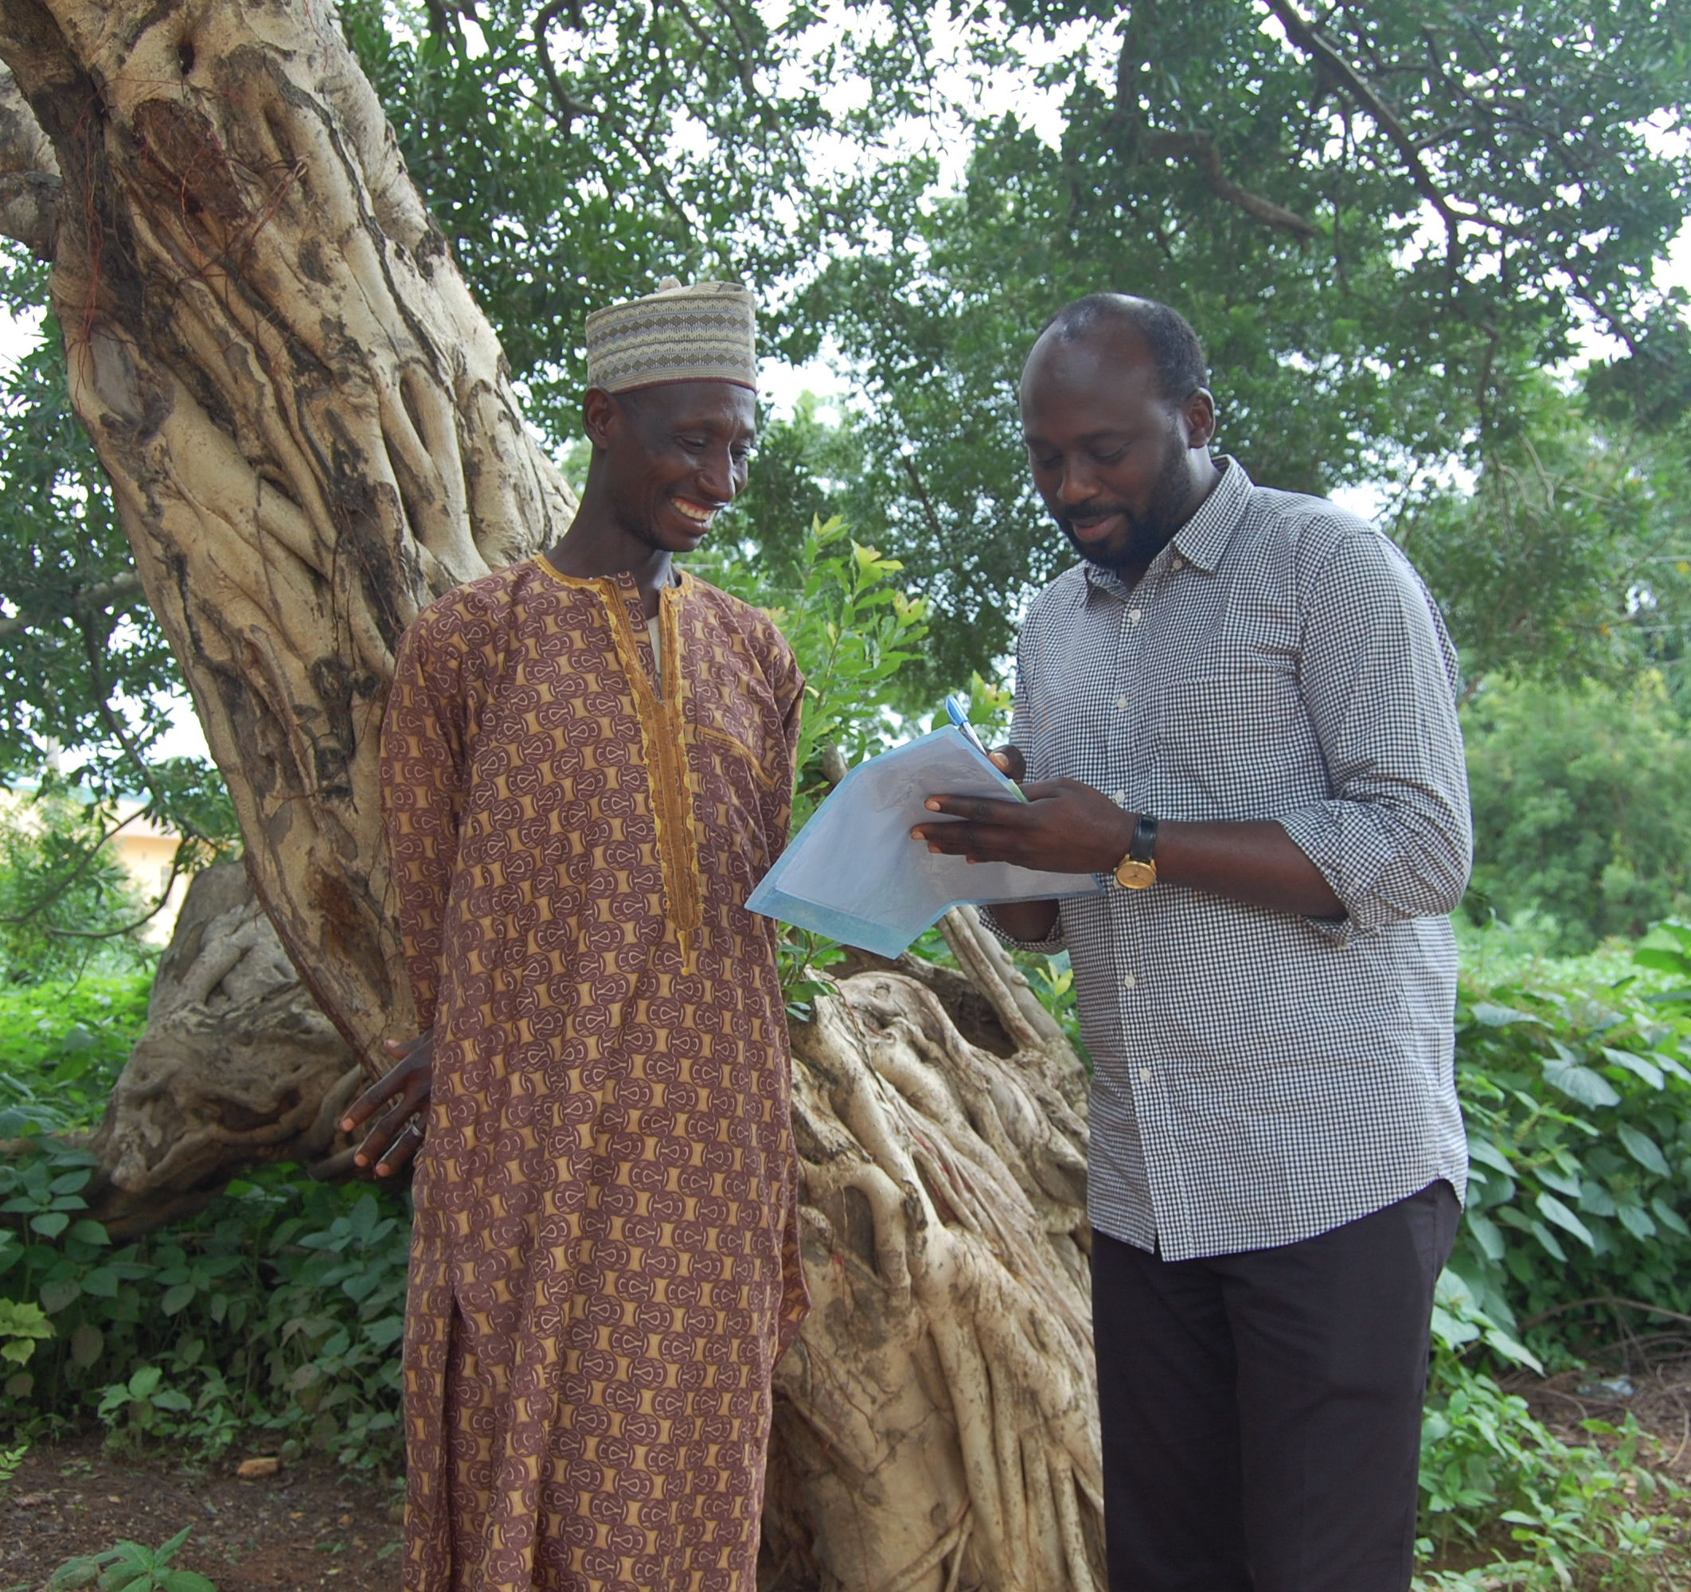
Budget Guidelines
Ascend Learning & Innovation Fund
Budget Guidelines

1. Introduction
These guidelines have been established for applicants to the Ascend West and Central Africa Learning and Innovation fund.
The purpose of this document is to provide clear guidance on the process for budgeting activities, and to clarify what will be allowable. Sightsavers and the other partners have a clear responsibility to ensure that this programme achieves its objectives and delivers value for money.
If you have any questions on these guidelines or on the budget template, please contact the Fund Team at fundteam@ascendwest-innovationfund.org.

2. Budgeting (including Budget updates)

2.1 The overall budgeting process
All Partners should adopt appropriate practices to ensure that best value is obtained for the project. Expenditure must be based on approved budgets but there are specific rules around certain costs to ensure that DFID are obtaining value for money.
Economies of scale may be achieved for all equipment and consumables through consolidated procurement at a national, regional or programme level. DFID must approve procurement of equipment in advance, so the Fund Team must be consulted before any procurement processes are undertaken.
Any potential conflict of interest should be declared to the Fund Team up front. Approval should be obtained from the Fund Team prior to undertaking any financial transaction with the party concerned.
Partners also need to be aware of the requirements of the UK Bribery Act. They should ensure that they do not undertake any activities that could be construed as bribery, such as providing facilitation payments. If you suspect any fraud in connection with expenditure incurred on this project you should immediately report it to the Fund Team, to Sightsavers (whistleblowing@sightsavers.org) or directly to DFID (reportingconcerns@dfid.gov.uk) as per the Whistleblowing Policy.

2.2 Budget templates and cost lines
During the application process, budgets need to be established using the budget templates provided by the Fund Team (summary budget). If your application is approved, there will be an additional requirement to provide a more detailed budget (detailed budget), showing the links to the activities you will undertake. In addition, reasonable requests for costs to be grouped in a certain way to enable fair comparison across Partners and countries may periodically occur. It is also likely that the Donors may have ad hoc requests relating to unit costs and value for money information during the period of the fund. You will be given as much notice as possible to provide this information.
We have provided the following information to help understand what should be included in your summary and detailed budgets.

Staff Time
Summary Budget: Please include a total for the staff costs, with information on the roles included in the budget notes.
Detailed Budget: Any staffing costs that are included must be itemised by person and by the % of their time that has been budgeted to the project. Pooled staffing costs, where costs are not allocated on the basis of time spent working on a specific project, will not normally be permitted to be directly charged.

Consultants
Any consultants who are budgeted at over £25,000 will require separate approval from DFID, and these positions may need to go through an external tendering process.
Summary Budget: Please include budget notes to indicate where the above is the case on your project.
Detailed Budget: Consultants must be itemised by person and by the number of days that have been budgeted to the project.

Equipment Spend
Please include any equipment or assets to be purchased for your project. Advance approval will be required for any spend on this line which falls within DFID’s definition of as asset.
Assets are classed as equipment and/or supplies which:
- Have a useful life of more than one year; and either
- The purchase price or development cost of the asset is in excess of £500 or equivalent in local currency; or
- The asset is part of a group of lower value items where the combined value is in excess of £500 or equivalent in local currency; or
- The asset can be considered an attractive item regardless of cost (e.g. mobile phones, cameras, laptops, tablets, satellite phones, vehicles, etc.)
The Organisation must ensure that any procurement using contract funds meets international good practice, untied and free of narrow national self-interest, using transparent processes, transparently fair and open competition, and good contract management, including prevention of malpractice, bribery and corruption.
The Organisation should source goods and services from suppliers that clearly offer value for money, and whose workplace practices meet corporate social responsibility standards.
Summary Budget: Please include budget notes with details of what is included in this line as this helps us determine whether donor approval will be required.

Digital Spend
Digital spend requires pre-approval from DFID. Please see guidance for whether your spend falls into this category here:
https://assets.publishing.service.gov.uk/government/uploads/system/uploads/attachment_data/file/842926/DFID-digital-guidance-for-partners-suppliers-Oct19.pdf
Summary Budget: Please include budget notes for this line to explain what your total is made up of.

Travel
Summary Budget: Please include a lump sum, with budget notes explaining the number of trips and destinations, etc.
Detailed Budget: Lump sums or provisions for travel will not be permitted. Average trip costs based on activity should be prepared.
Additional information on what should be considered when budgeting for travel is included below.

Accommodation
Hotels used should provide secure and comfortable but not luxurious accommodation, such that those working on the project are in a fit state to carry out their duties during the day. 5* hotels or their equivalent will not be funded (expenditure will be rejected) and an explanation should be provided in circumstances where it has proved necessary to use a hotel that is above mid-range. The Fund Team will not accept the following hotel related expenses:
- Newspapers
- Mini bar drinks and snacks
- Video / television charges for in room movies
- “no show” costs
- Laundry
- Tips or gratuities
- Alcoholic drinks
For locations where hotel accommodation is not available, an accommodation allowance may be claimed.

Meals and Drinks
Meals and an accompanying non-alcoholic drink will be accepted subject to the retention of a valid receipt and confirmation of number of covers. Records retained should make it clear that only personnel working on the project are being claimed for and that the cost per person is reasonable given the location. Where hotel meals are included in the total price (such as breakfast) an alternative meal option is not allowable. Additional water/non-alcoholic drinks required during the day are an acceptable expense.
Please be aware that DFID have changed their policy and alcohol can no longer be charged to the programme.

Modes of Travel
Internal or international flights needed for the purposes of the project can be charged where budgeted. Booking invoices and boarding passes should be kept as evidence of flights taken. Only flights with a class of travel that is no more than ‘standard economy’ are reimbursable.
Organisations are expected to claim using their standard mileage rate (to cover the cost of fuel and a % add on for maintenance and insurance). All mileage rates should be approved as part of budget with the submission of the basis of calculation. When claiming for mileage, details of distance covered and places visited will be needed and it is expected that authorised vehicle log books will be retained as evidence of mileage covered.
Where organisations do not have a mileage rate, fuel receipts will be reimbursed, again accompanied by details of mileage undertaken and places visited, substantiated by authorised vehicle log books. Reasonable vehicle repair and maintenance costs relating specifically to project activities will be funded, subject to overall budget ceiling.
Costs of public transport and taxis incurred in the course of project business, including travel to and from airports, may be claimed if there is supporting documentation such as a valid receipt. Taxis are a very expensive way to travel in some countries and should be avoided in favour of buses and trains where possible. Receipts must be obtained for any taxi fares and an explanation given where there is no receipt. Tickets should be retained for any other forms of land transport.
It is expected that partner organisations will usually be able to use their own, Ministry of Health, or project vehicles for project activities. However, if it is anticipated that vehicle hire will be necessary this should be included in the project budget and be properly documented with a contract for vehicle hire and invoices for payment. The Fund Team will not fund vehicle hire payments if it is apparent that the vehicle has not been used solely for project activities, so clear records of mileage undertaken and locations visited should be retained.

Per Diems
If it is standard practice for your organisation to fund expenses using per diems, this should be reflected in the budget. Per diem rates must be approved at the budget stage and it should be clear what is covered by the per diem rates used (e.g. some cover accommodation and some do not). Receipts for other categories of expenditure referred to in these guidelines (such as accommodation, food, travel, telephone) will not be refunded where there has been payment of a per diem to cover these.
In general, per diem rates should be based on an appropriate scale (e.g. government rates, set rates per organisational policy). Per diem rates for Ministry of Health staff should be standard across partner budgets in any one country.
Per diem payments should be documented by signature and formal receipt from the person who has received the payment, and where at all possible should be paid by bank transfer rather than cash.

Other Activity Costs
Any direct costs relating to your project activity which have not been included elsewhere should be included here. Please include budget notes explaining what this figure is made up of.

Venue Hire
Training activities may require hire of an appropriate conference venue. Negotiation of ‘cost per delegate’ packages is acceptable. It is expected that appropriate procurement practices are applied to ensure a competitive price, providing good value for money.

Other Support Costs
In-country office running costs that can be directly attributable to the project may be budgeted here, along with other direct costs which do not fit into other categories. As this is a broad category, please include information in the “Notes” column.

Phone Costs
Where it can be demonstrated that additional mobile phone costs have been incurred, these can be claimed. Airtime vouchers or mobile phone invoices should be kept to record this expenditure. Excessive mobile phone claims will be queried as this expenditure should only relate to calls necessary to project activities when out in the field.
Landline calls and data usage charges incurred in connection with the project can be funded to the extent clearly identifiable on phone bills. Additional contributions to line rental etc. are not allowable.

2.3 Lump sums and units in budgets
Detailed Budgeting (after project approval): Lump sums should be avoided in budget lines and may not be approved.

2.4 Things to remember when budgeting
The following resources are often necessary for running an NTD project (depending on the activities) but are often left out of the budgets prepared.
- Staff related costs (e.g. recruitment costs, training, benefits and statutory payments).
- National planning and other evaluation meeting costs
- Vehicle maintenance and running costs
- Equipment maintenance (e.g. for photocopiers and computers)
- Surgery audit costs
- Shipping and clearance taxes

2.5 Budget notes
All budgets submitted should be accompanied by budget notes clearly explaining how the costs are required for the activities and outputs agreed.
These should be included in the ‘Notes’ column of the budget template. The notes should allow someone to understand what each line is, why it is necessary for the project and how it has been calculated. They should be structured in terms of unit costs e.g. how did we calculate the unit cost, what does it include, what is the number of units.

2.6 Budget ceiling
All Partner expenditure reports are subject to the approved ceiling for each budget subheading. This corresponds to the agreed activities for that period. Any expenditure within a budget subheading in excess of 10% of the budget ceiling must be identified and approval sought from the Fund Team prior to committing to the expenditure
Only financial expenditure reports that are within the agreed budget ceiling will be approved. Please bear this in mind when budgeting.

